HR Analytics Dashboard – KPI Documentation
This document explains the Key Performance Indicators (KPIs) derived from the HR Dashboard and provides insights based on the visualizations.

1️⃣ Workforce Structure KPIs

Total Headcount
Definition: Total number of active employees in the organization.
Insight: Indicates overall workforce size and company scale.

Department-wise Headcount
Definition: Number of employees in each department.
Insight: Helps identify manpower allocation and dominant functional areas.
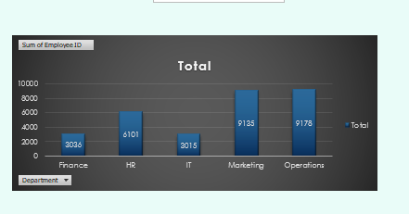

Location-wise Workforce Distribution
Definition: Distribution of employees across different cities.
Insight: Identifies regional workforce concentration and expansion areas.
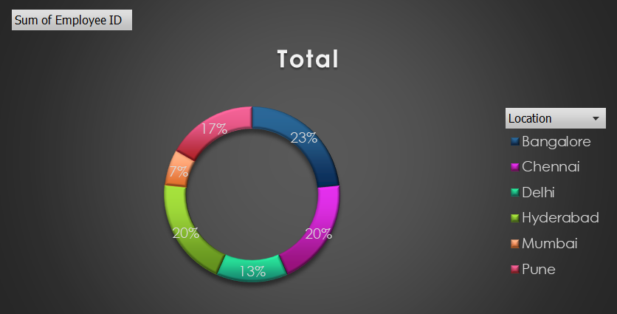

Age Band Distribution
Definition: Employees grouped by age categories.
Insight: Shows workforce maturity and succession planning readiness.
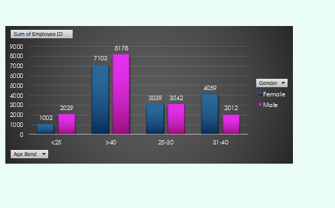

2️⃣ Diversity & Inclusion KPIs

Overall Gender Distribution
Definition: Total male vs female employee representation.
Insight: Indicates gender balance and diversity strength.
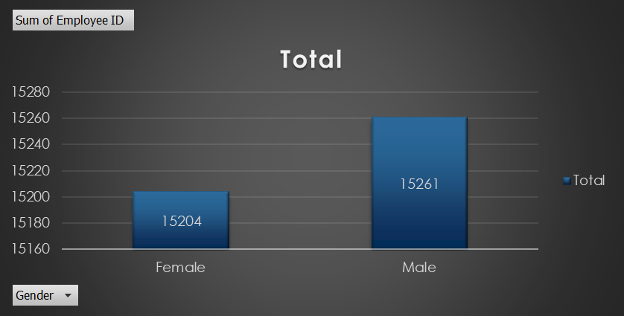

Gender Mix by Hiring Source
Definition: Gender distribution across recruitment channels.
Insight: Identifies whether hiring channels promote balanced diversity.
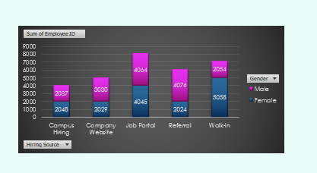

3️⃣ Hiring & Recruitment KPIs

Hiring Source Effectiveness
Definition: Number of employees hired through each recruitment source.
Insight: Helps determine the most productive hiring channel.
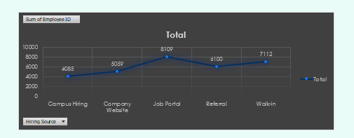

4️⃣ Strategic HR Insights
• Marketing and Operations departments have the highest workforce concentration.
• Job Portal is the most effective hiring source.
• Workforce shows balanced gender representation.
• Majority of employees fall in mid-to-senior age bands, indicating experienced workforce.
• Workforce is evenly distributed across major metro locations.

